Friends of Greaves Park
The Wildlife of The Galapagos Islands
An illustrated talk by
Steve Bullen
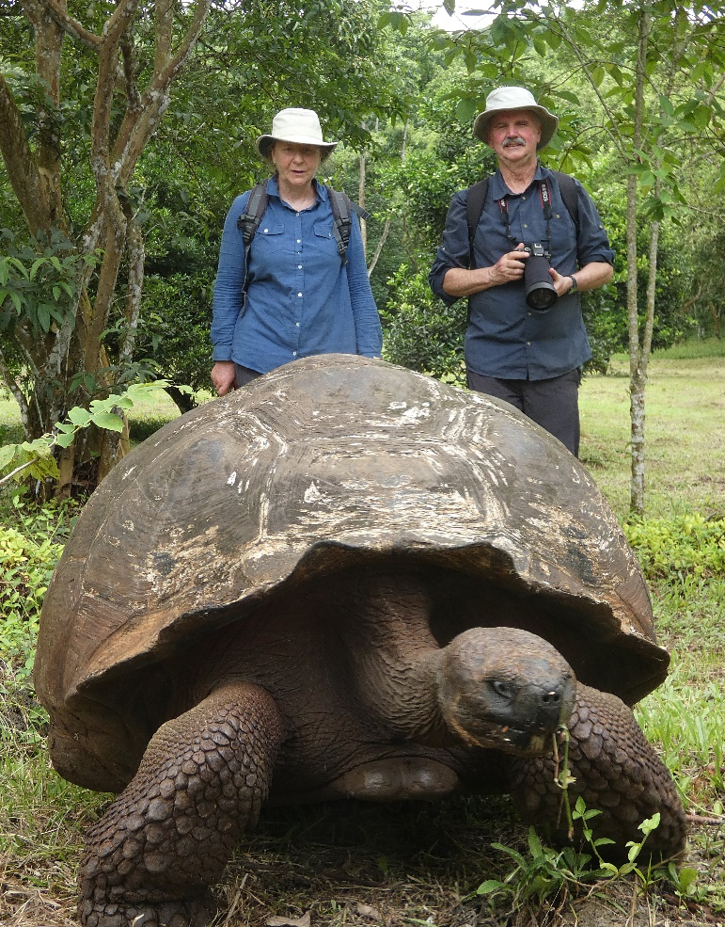

Thursday 12th November 7 pm.
At United Reform Church Hall,
Bowerham Road, Lancaster.
£2.50 admission
(part of the proceeds will go towards Friends of Greaves Park environmental work)

